THIRD GRADE MATHEMATICS
UNIT 6 STANDARDS
Dear Parents,

We want to make sure that you have an understanding of the mathematics your child will be learning this year. Below you will find the standards we will be learning in Unit Six. Each standard is in bold print and underlined and below it is an explanation with student examples. Your child is not learning math the way we did when we were in school, so hopefully this will assist you when you help your child at home. Please let your teacher know if you have any questions.
☺

MGSE3.MD.1 Tell and write time to the nearest minute and measure time intervals in minutes. Solve word problems involving addition and subtraction of time intervals in minutes, e.g., by representing the problem on a number line diagram.
This standard calls for students to solve elapsed time, including word problems. Students could use clock models or number lines to solve. On the number line, students should be given the opportunities to determine the intervals and size of jumps on their number line. Students could use pre-determined number lines (intervals every 5 or 15 minutes) or open number lines (intervals determined by students).

Example:
Tonya wakes up at 6:45 a.m. It takes her 5 minutes to shower, 15 minutes to get dressed, and 15 minutes to eat breakfast. What time will she be ready for school?
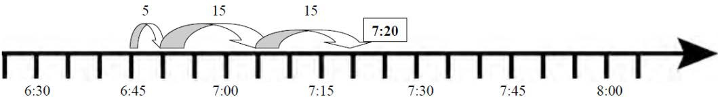

MGSE3.MD.2 Measure and estimate liquid volumes and masses of objects using standard units of grams (g), kilograms (kg), and liters (l).¹ Add, subtract, multiply, or divide to solve one-step word problems involving masses or volumes that are given in the same units, e.g., by using drawings (such as a beaker with a measurement scale) to represent the problem.²
This standard asks for students to reason about the units of mass and volume. Students need multiple opportunities weighing classroom objects and filling containers to help them develop a basic understanding of the size and weight of a liter, a gram, and a kilogram. Milliliters may also be used to show amounts that are less than a liter. Word problems should only be one-step and include the same units.

Example:
Students identify 5 things that weigh about one gram. They record their findings with words and pictures. (Students can repeat this for 5 grams and 10 grams.) This activity helps develop gram benchmarks. One large paperclip weighs about one gram. A box of large paperclips (100 clips) weighs about 100 grams so 10 boxes would weigh one kilogram.
Example:
A paper clip weighs about a) a gram, b) 10 grams, c) 100 grams?

Foundational understandings to help with measure concepts:
- Understand that larger units can be subdivided into equivalent units (partition).
- Understand that the same unit can be repeated to determine the measure (iteration).
- Understand the relationship between the size of a unit and the number of units needed (compensatory principle).

Common Misconceptions
Students may read the mark on a scale that is below a designated number on the scale as if it was the next number. For example, a mark that is one mark below 80 grams may be read as 81 grams. Students realize it is one away from 80, but do not think of it as 79 grams.

MGSE3.MD.3 Draw a scaled picture graph and a scaled bar graph to represent a data set with several categories. Solve one- and two-step “how many more” and “how many less” problems using information presented in scaled bar graphs. For example, draw a bar graph in which each square in the bar graph might represent 5 pets.

This standard continues throughout the third grade year.

Students should have opportunities reading and solving problems using scaled graphs before being asked to draw one. The following graphs all use five as the scale interval, but students should experience different intervals to further develop their understanding of scale graphs and number facts. While exploring data concepts, students should Pose a question, Collect data, Analyze data, and Interpret data (PCAI). Students should be graphing data that is relevant to their lives.
Example:
Pose a question: Student should come up with a question. What is the typical genre read in our class?
Collect and organize data: student survey

Pictographs: Scaled pictographs include symbols that represent multiple units. Below is an example of a pictograph with symbols that represent multiple units. Graphs should include a title, categories, category label, key, and data. How many more books did Juan read than Nancy?

Number of Books Read
Nancy
Juan
= 5 books

Single Bar Graphs: Students use both horizontal and vertical bar graphs. Bar graphs include a title, scale, scale label, categories, category label, and data.
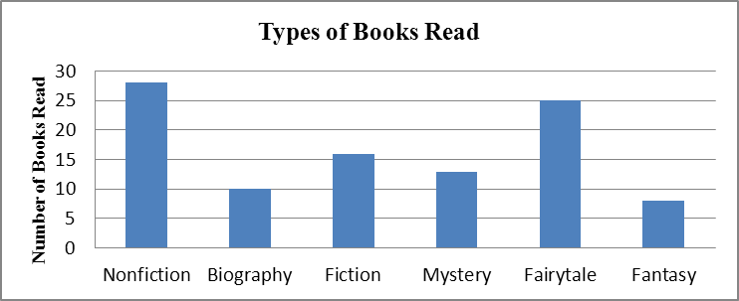

Analyze and Interpret data:
  - How many more nonfiction books where read than fantasy books?
  - Did more people read biography and mystery books or fiction and fantasy books?
  - About how many books in all genres were read?
  - Using the data from the graphs, what type of book was read more often than a mystery but less often than a fairytale?
  - What interval was used for this scale?
  - What can we say about types of books read? What is a typical type of book read?
  - If you were to purchase a book for the class library which would be the best genre? Why?

MGSE3.MD.4 Generate measurement data by measuring lengths using rulers marked with halves and fourths of an inch. Show the data by making a line plot, where the horizontal scale is marked off in appropriate units – whole numbers, halves, or quarters.
This standard continues throughout the third grade year.

Students in second grade measured length in whole units using both metric and U.S. customary systems. It is important to review with students how to read and use a standard ruler including details about halves and quarter marks on the ruler. Students should connect their understanding of fractions to measuring to one-half and one-quarter inch. Third graders need many opportunities measuring the length of various objects in their environment. This standard provides a context for students to work with fractions by measuring objects to a quarter of an inch.
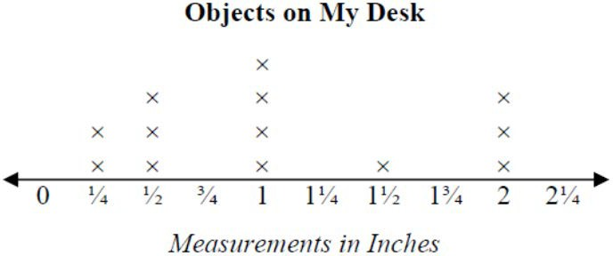
Example: Measure objects in your desk to the nearest ½ or ¼ of an inch, display data collected on a line plot. How many objects measured ¼? ½? etc. …

