Unit 1 Major Assessment STUDY GUIDE
Standards: NR 2.1, NR 2.2, NR 1.1, NR 1.2

- Add 10 + 6 to find the sum.
10 + 6 = _____

- Add 10 + 3 to find the sum.

10 + 3 = _____

- Add using the models below.

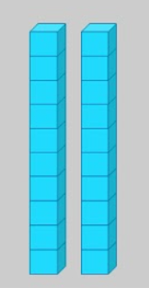 + =_____

- Subtract using the models below.
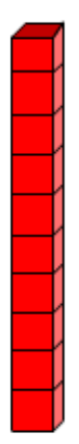- 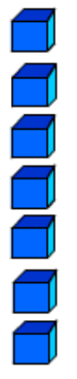= _____

- Follow the pattern: 10, ______, 30, 40, ________, 60.

- Follow the pattern: 40, ______, 60, 70, ________, 90.

- Write this number in expanded form: 237

- Write this number in expanded form: 154

- Represent the number with base ten blocks: 42

- Represent the number with base ten blocks: 71

- Fill in the hundreds chart examples:

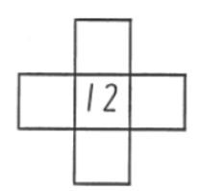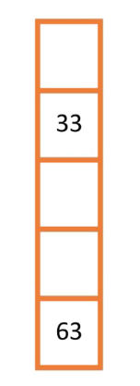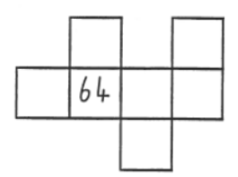

- Solve to find the difference.

18 – 6 = ______

- Solve to find the difference.

16 – 5 = ______

